Lesson 03 Demo 03

Blob Lifecycle Management Policy

Objective: To implement blob lifecycle management policy to store the data in a
cost-effective manner in Azure

Tools Required: None

Prerequisites: A storage account

Steps to be followed:
- Create a blob lifecycle management policy

Step 1: Create a blob lifecycle management policy

- Login to the Azure portal, select Storage accounts, and choose simplilearnstoragedemo3

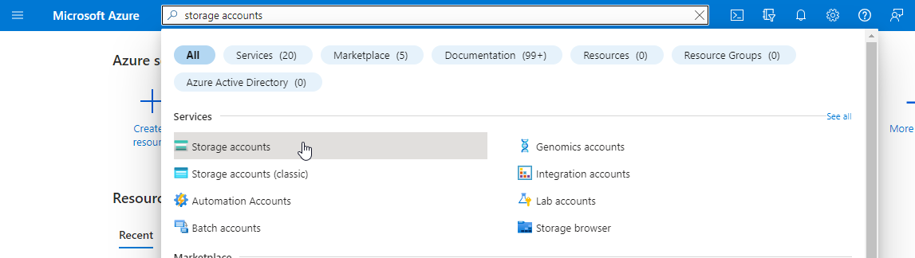

- Within simplilearnstoragedemo3, navigate to Lifecycle management to view or modify the existing lifecycle management policies

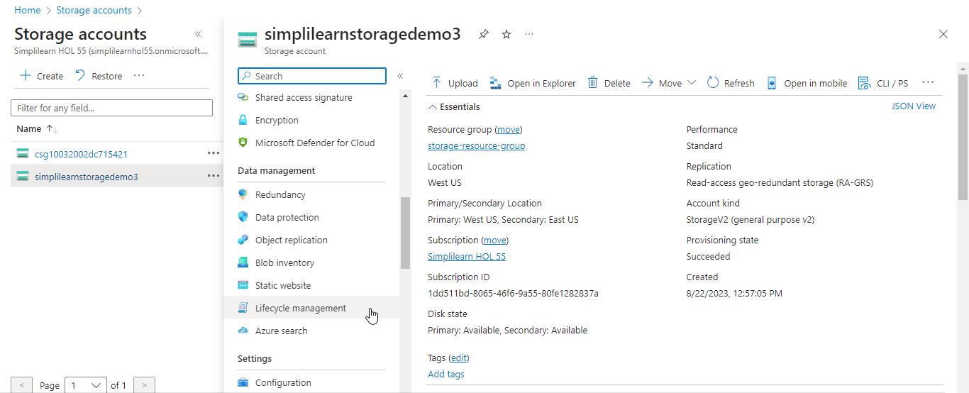

  - After selecting Lifecycle management, click on Add a rule

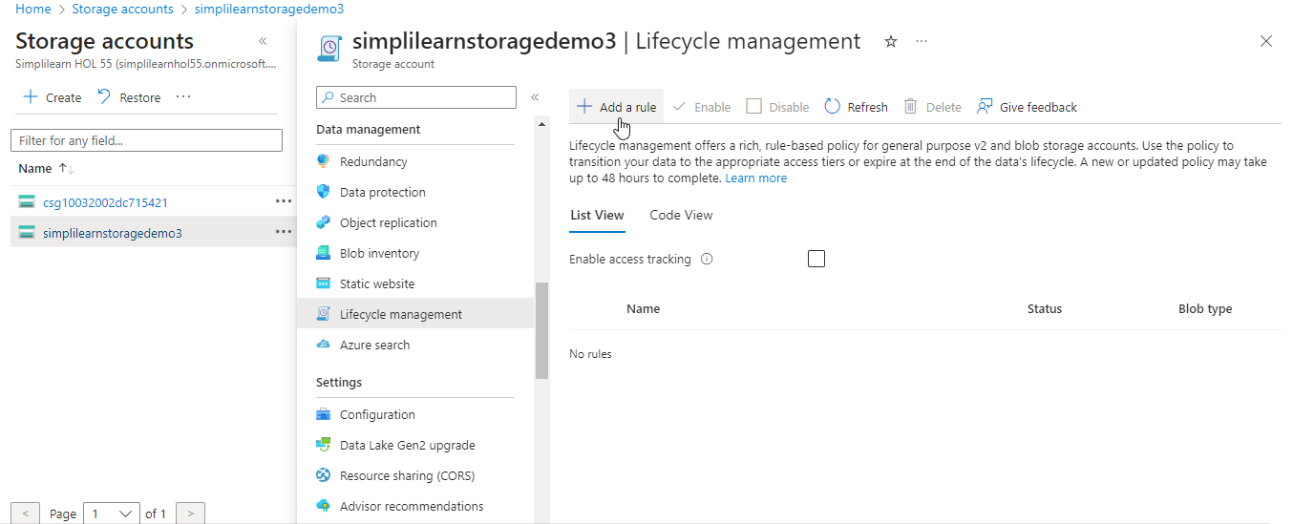

  - On the Details tab, enter the Rule name. Set values for the Rule scope, Blob type, and Blob subtype. In the following example, the scope is set to filter blobs, which adds the Filter set tab.

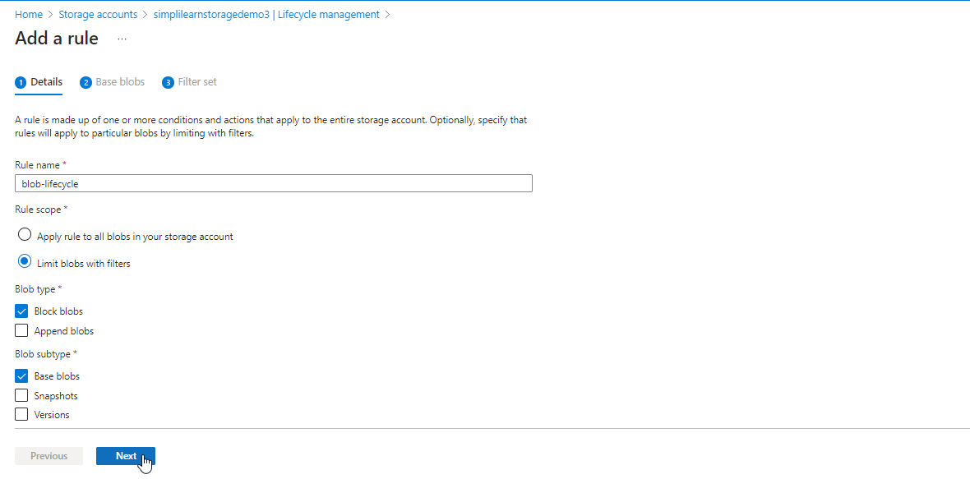

  - Select Base blobs to set the conditions for the rule. In the following example, blobs are moved to cool storage if they haven't been modified for 30 days.

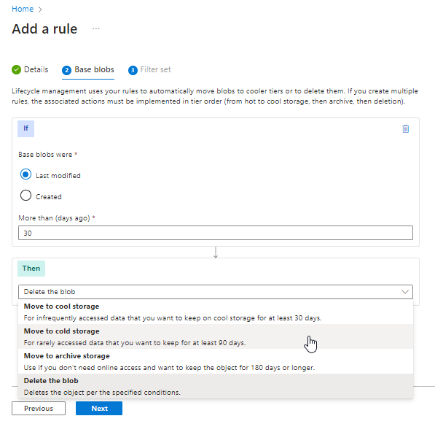

  - If Limit blobs with filters were selected on the Details page, select Filter set to add an optional filter. In the following example, blobs with names that start with capture in a container named container1 are filtered. Select Add to add the new policy.

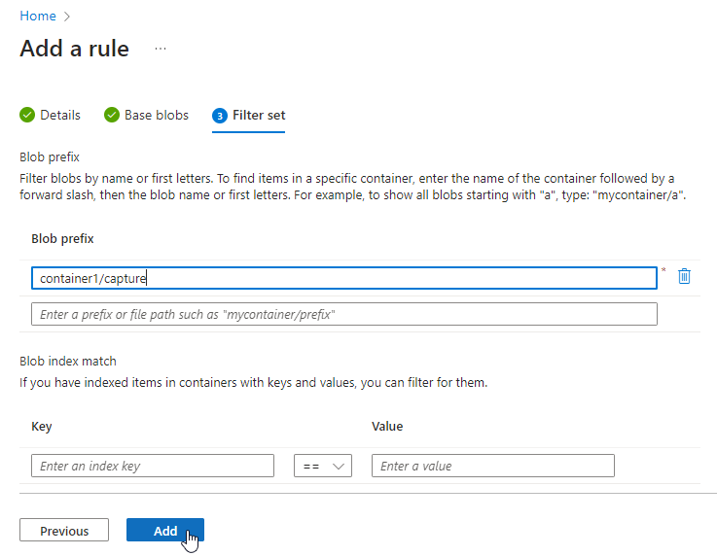

You have now successfully implemented the lifecycle policies on blob to store data in a cost-effective manner in Azure.

